**CHAPTER 1**

**INTRODUCTION**

* 1. **INTRODUCTION**

Nutritional components and calories are a must for the body, as they generate energy. But it is said that an excess of anything is bad and the same applies to the intake of calories too. If there is an excess of calories in our body, it gets stored in the form of fats, thus making us overweight. Adult calorie requirements differ from that of a child and in the same way, the daily calorie requirement of Body Mass Index (BMI) is a person’s weight in kilograms divided by the square of their height in meters. It is one of the most commonly used ways of estimating whether a person is overweight or not.

The rate of obese person is increasing at an alarming rate from last few years. Also, there are many chances for obese people to face serious health problems like hypertension, heart attack, diabetes, obesity, high cholesterol etc. So the main cause for obesity is imbalance of the amount of food intake and energy consumed by the individual since it is necessary to have healthy meal. As the like for trend and variety of fast food items is increasing, people are also becoming more aware and conscious about calorie intake as the higher number of calorie intake creates a lot of problems that invokes the need of medical consultancy.

People suffering from such problems require an easy way to control their calorie whereas others take it as a step towards prevention. Thus, Maintaining a healthy diet is an important goal for many people. One way to achieve this is by tracking the amount of calories consumed, this tracking process can be very tedious as it requires the user to keep a food journal and to do messy calculations to be able to estimate the amount of calories consumed in every food item.

Recently, automatic ways to calculate the amount of calories consumed in a food item have been surfacing. The goal of machine learning is to give computers the ability to do something without being explicitly told how to do it. We just provide some kind of general structure and give the computer the opportunity to learn from experience, similar to how we humans learn from experience too. Fascinated by this technology of deep convolution neural networks. In this project, we proposed to alleviate the user from the burden of entering the above information in order to calculate the number of calories consumed in a food item.

This is particularly beneficial when such information is difficult to obtain. In today’s world everything is almost done digitally and it leads to problems like weight gain, obesity, cholesterol etc., thus it has become very important for people to keep fit. A healthy diet can be maintained by keeping track of the amount of calories consumed in the form of food on a daily basis.

* 1. **PROBLEM STATEMENT**

The majority of the population suffers from obesity and overweight that presents risk to health. It is a major concern that leads to serious life threatening illness like heart disease, stroke, high Blood Pressure and diabetes.

It becomes inevitable to keep track of food intake and to keep everything on track by maintaining daily food habits on a dairy.

How can we combat this through technical methods such as Machine Learning by

automating the Calorie and Nutrition Estimation ?

* 1. **LITERATURE SURVEY**
     1. **Inception-V3 Based CNN**

[2] Viswanath C, et al proposes a method to classify Indian food images by adopting a Google Inception-V3 based convolutional neural networks (CNNs) model. Here they have used convolution layer that is able to create its own convolution kernel in order to convolve with input layer to generate the tensor outputs. The Max-Pooling function is used for features extraction from the data and help to train the CNN model. The dataset contains data from the Yummly API and some real time south-Indian food data where some of the training and testing images has some noise, different colour intensity and images with the wrong-labels. All the food images are separated into their respective class folder and labelled properly.

For pre-processing of image several necessary parameters have been considered such as fill mode, Horizontal flip, rotate angle, height-shift range, and width-shift range. The height shift range is considered as 0.2 and the width shift range is also considered as 0.2. The proposed model utilizes the custom Inception-V3 weights which are pre-trained using ImageNet and it considers the reshaped size of 150×150×3 for all images. The function of average pooling is considered at the food image dataset, where it takes the average of image features and the dimensionality of space output is defined via the dense-function. A total of 16 classes are considered which contain 2149 number of images, for the testing purpose 20% of total images are used (i.e., randomly selected from all classes) and 80% remaining image for training purposes. Proposed model has been tested on self-collected cuisine dataset and manages to get 96.27% classification accuracy.

**Advantages:**

* With transfer learning a solid machine learning model can be built with comparatively little training data because the model is already pre-trained.
* The model obtained great accuracy.

**Disadvantages:**

* The dataset used is relatively small.
* Training times for transfer learning models is high.
  + 1. **Multi SVM Classifier**

[3] Manpreetkour Basantsingh, et al proposes an algorithm for fruit recognition and its calorie measurement based on the shape, colour and texture along with histogram of gradients and GLCM with local binary pattern algorithms for texture segmentation scheme recognizing the fruits and area, major axis, minor axis are calculated by using shape feature to get more accurate calorie value. With the help of nutritional look up table these features are fed to multi SVM classifier for accurate classification. For dataset, five categories of fruit images are captured using Samsung grand prime mobile phone and the images acquired were 3264 x 1836 pixels in size. Pre-processing steps such as rgb to gray conversion, filtering, resizing to 256 x 256, adaptive histogram equalization is carried out. The histogram of oriented gradients (HOG) is a feature descriptor used for the purpose of object detection. For obtaining the accurate features appropriate segmentation scheme is used.

This section consists of three features namely shape, colour, and texture. For shape based feature extraction the geometrical region parameters like area, major axis and minor axis are calculated. For colour based segmentation the HSV histogram is used. The gray level co-occurrence matrix (GLCM) is used to calculate different texture features. Classification with the multi class support vector machine (SVM) has been done. All the features of each fruit item are extracted during the segmentation phase and then used as training vectors and stored database for the multi class SVM. The system initiates to calculate the calories by comparing the inputs from the feature vector with the inputs from the nutrient tables (mass measured in gram and calorie in calories or kilo calories). The result of recognition rate is calculated with the help of equation : RR= No of correctly recognized samples100 Total samples Average RR of model was 97%. The average Accuracy of calorie measurement is 98.82%.

**Advantage:**

* Support Vector Machine (SVM) model achieves great accuracy for multiclass image classification.

**Disadvantage:**

* Volumetric based calculation for determining calories is not an efficient method.
  + 1. **K-Nearest-Neighbour**

[4] Pathanjali C, et al propose an automatic food detection system that detects and recognizes varieties of Indian food. The proposed food recognition system is developed in such a way that it can classify the Indian food items based on two different classification models i.e. SVM and KNN. The proposed system uses a combined color and shape features. A comparative study on the performance of both the classification models is performed. Parameters such as food density tables, color and shape acknowledgment as a part of image processing, and classification with the SVM and KNN have been considered. The data set contains the feature vector extracted from the sample images. They have considered around 200 image samples with cluttered food and individual food items. They have considered two combined features for these 200 samples we have considered 80% of the images as training set and 20% of them as the testing set.

The pre-processing stage includes 3 stages: a. RGB to HSV color conversion, b. b. Noise removal, c. c. image cropping and d. d. edge detection. The food is categorized based on the labels of its *k*-nearest neighbors by the maximum number of votes. Classification is performed by comparing features from the image and the dataset. In proposed paper the feature extracted are plotted on the graph. To plotted graph, the classification methods (KNN& SVM) are applied to predict the class based on the color and shape feature. The hyper plane is drawn between points which differentiate the two classes. SVM had an average accuracy of 82% and KNN had accuracy of 75.6%.

**Advantages:**

* For preprocessing, various image processing techniques have been considered, leading to better accuracy.

**Disadvantage:**

* K- Nearest Neighbours (KNN) does not provide good accuracy.
  + 1. **Support-Vector-Machines**

[5] Hemraj Raikwar, et al proposes a model which focuses on estimation of number of calories in the food item by just taking its image as input using SVM. The proposed model applies some techniques of image processing followed by feature extraction. The authors designed the dataset, applied this dataset to some image processing techniques, then processed dataset is applied to the feature extraction process. The features extracted for all the images are then applied to the classifier support vector machine (SVM) which classifies the images in different classes as specified in the learning algorithm. The model consists of several intermediate activities which are: a. extracting the feature vector of image, b. identify the food item in the image, c. predict the calorie content of the food item in the image The dataset includes images from PFID (Pittsburgh Fast Food Image Dataset) and website of Shutterstock and calorie information from nutrition. The images are labelled alphabetically and divided the images into 5 different categories- Pizza, Burger, Donut, Burrito and Samosa. For pre-processing - It includes background subtraction to remove noise and unnecessary information.

Augmentation is performed to provide a 360-degree view of the object to be identified. Resizing of image is done. Histogram of Oriented Gradients (HOG) is calculated on each image after scaling the images to 120x120 resolution. They calculated Histogram of Oriented Gradients (HOG) by taking cell size of 5x5 pixels and block size of 3x3 cells. HOG provides a single dimensional vector as feature descriptor. Support Vector Machine (SVM) with linear kernel is used because it provides better results than other kernels. The model achieved an accuracy of 90.66%.

**Advantage:**

* The results show a good accuracy and support the power of SVM algorithms in pattern recognition.

**Disadvantage:**

* Dataset limited to a subset fast food images only , hence reducing the number of classes for classification.
  + 1. **Deep based Architecture (Zero-shot Retrieval)**

[1] Jingjing Chen and Chong-Wah Ngo, et al proposes a method of Food Categorization, Ingredient Recognition, Zero-shot retrieval. This paper studies the recognition of ingredients for recipe retrieval in the domain of Chinese dishes.

Retrieving recipes corresponding to given dish pictures facilitates the estimation of nutrition facts, which is crucial to various health relevant applications. The current approaches mostly focus on recognition of food category based on global dish appearance without explicit analysis of ingredient composition. Such approaches are incapable for retrieval of recipes with unknown food categories, a problem referred to as zero-shot retrieval. On the other hand, content-based retrieval without knowledge of food categories is also difficult to attain satisfactory performance due to large visual variations in food appearance and ingredient composition. As the number of ingredients is far less than food categories, understanding ingredients underlying dishes in principle is more scalable than recognizing every food category and thus is suitable for zero-shot retrieval. Nevertheless, ingredient recognition is a task far harder than food categorization, and this seriously challenges the feasibility of relying on them for retrieval.

This paper proposes deep architectures for simultaneous learning of ingredient recognition and food categorization, by exploiting the mutual but also fuzzy relationship between them. The learnt deep features and semantic labels of ingredients are then innovatively applied for zero-shot retrieval of recipes. By experimenting on a large Chinese food dataset with images of highly complex dish appearance, this paper demonstrates the feasibility of ingredient recognition and sheds light on this zero-shot problem peculiar to cooking recipe retrieval.

**Advantages:**

* It Integrates and Exploits multiple high–level CNN features from different models, resulting in high accuracy, stability, and robustness.

**Disadvantages:**

* They cannot obtain a satisfactory on large scale complex datasets.
* There is a lack of large scale food dataset for food recognition, existing works mainly focus on utilizing smaller datasets for food recognition.
  + 1. **Convolutional Neural Network**

[6] Hokuto Kagaya and Kiyoharu Aizawa, et al proposes a method Food recognition, food detection using Convolutional Neural Network.

In this paper, applied a Convolutional Neural Network (CNN) to the tasks of detecting and recognizing food images. Because of the wide diversity of types of food, image recognition of food items is generally very difficult. However, deep learning has been shown recently to be a very powerful image recognition technique, and CNN is a state-of-the-art approach to deep learning. Here applied CNN to the tasks of food detection and recognition through parameter optimization.

Here constructed a dataset of the most frequent food items in a publicly available food-logging system, and used it to evaluate recognition performance. CNN showed significantly higher accuracy than did traditional support-vector-machine-based methods with handcrafted features. In addition, Here found that the convolution kernels show that colour dominates the feature extraction process. For food image detection, CNN also showed significantly higher accuracy than a conventional method did.

**Advantages:**

* Using CNN, it occurs great accuracy in Food image recognition problems.
* It has attributed large modelling capacity and significant advancement in network training.

**Disadvantage:**

* Lack of ability to be spatially invariant to the input data.
  1. **PROPOSED SYSTEM**

The proposed software model using machine-learning as the base which recognizes the food image uploaded as an input by the user, process the food image, recognize the food image and estimate the calories of predicted image. The application will then display the class of provided food image along with its estimated calories, thus helping users in diet management and reducing the need for manual/pen-paper approach. Food image recognition and calorie estimation can aid in diet management, food logging and recognizing local foods.

* 1. **ADVANTAGES OF PROPOSED SYSTEM**

The proposed system will be a significant alternative to the traditional method of food classification which is otherwise a tedious process and difficult to reach a good and considerable accuracy. Our proposed system has the following advantages which can serve as the better alternative to the traditional method of food classification and nutritional assessment.

* Clean and understandable User Interface Design using tkinter.
* Module based division in the UI to analyse Fruits/Vegetables and Desi Dishes separately.
* A detailed nutritional values report generation in the end of the process in contrast to only Calorie estimation in conventional methods.
  1. **OBJECTIVES**
* To detect the image of the Food using input images.
* To devise an algorithm which can accurately predict the food item from the given food image.
* The project aims at estimating the calories contained in the given food item, by devising an algorithm trained on various nutritional information.
* Reducing the manual approach for users to keep track of their calorie intake.

**CHAPTER 2**

**SYSTEM REQUIREMENTS SPECIFICATION**

A requirements specification for a software system is a complete description of the behaviour of a system to be developed. In addition to a description of the software functions, the requirement specification also contains functional, non-functional requirements and feasibility study. Software requirements are a sub-field of software engineering that deals with the elicitation, analysis, specification, and validation of requirements for software.

**2.1 HARDWARE REQUIREMENTS**

* System : Pentium IV 2.4 GHz/inteli3/i4,etc.
* Hard Disk : 250 GB.
* Monitor : 15 VGA Colour.
* Ram : 4GB Minimum

**2.2 SOFTWARE REQUIREMENTS**

* Operating system : Windows 7 or More
* Software Packages : Tensorflow 1.14 , OpenCV
* Coding Language : Python.
* Toolbox : Image processing toolbox.
* IDE : Python, Jupyter Notebook, IDLE

**2.3 FUNCTIONAL REQUIREMENTS**

The functional requirements must explicitly impart the functions that are provided by the proposed system. Useful requirements describe the product's internal activities: that is, the technical subtleties, monitoring and handling of data and other specific functionality demonstrating how to satisfy the use cases. They are upheld by non-utilitarian prerequisites that force the plan or execution of imperatives.

* System should Process the data.
* System Should Segment the image.
* System should detect the Food.
* System should predict Nutritional details using Food images.

**2.4 NON-FUNCTIONAL REQUIREMENTS**

Unnecessary prerequisites are requirements that suggest parameters that can be used to assess a framework's operation rather than specific activities. This should be distinguished from useful necessities indicating explicit behaviour or capabilities. Reliability, flexibility, and price are common non-practical necessities.

Non-practical preconditions are often referred to as system utilities. Different terms for non-practical necessities are "limitations, “quality characteristics" and "prerequisites for administration". On the off chance that any special cases occur during the product execution, it should be obtained and keep the framework from slamming along these lines. The architecture should be created in order to incorporate new modules and functionalities, thereby promoting application development. The cost should be small as a result of programming packages being freely accessible.

* Usability System Should be user Friendly.
* Reliability System should be Reliable.
* Performance System Should not take excess time in detecting.
* Supportability System should be easily updatable for future enhancement.

**2.5 FEASIBILITY STUDY**

The feasibility of the project is analysed and business proposal is put forth with a very general plan for the project and some cost estimates. During system analysis the feasibility study of the proposed system is to be carried out. This is to ensure that the proposed system is not a burden to the organization. For feasibility analysis, some understanding of the major requirements for the system is essential.

Three key considerations involved in the feasibility analysis are:

* Economic Feasibility
* Technical Feasibility
* Operational Feasibility

**2.5.1 ECONOMIC FEASIBILITY**

Economic Feasibility study is carried out to check the economic impact on the system and on the organization. The amount of fund that the organization can pour into the research and development of the system is limited. The expenditures must be justified. Thus, the developed system as well within the budget and this was achieved because most of the technologies used are freely available. Only the customized products have to be purchase.

**2.5.2 TECHNICAL FEASIBILITY**

Technical feasibility study is carried out to check the technical feasibility, that is, the technical requirements of the system. Any system developed must not have a high demand on the available technical resources. This will lead to high demands being placed on the client. The developed system must have a modest requirement, as only minimal or null changes for the implementing this system.

**2.5.3 OPERATIONAL FEASIBILITY**

Operational feasibility study is to check the level of acceptance of the system by the user. This includes the process of training the user to use the system efficiently. The user must not feel threatened by the system, instead must accept it as a necessity. The level of acceptance by the users solely depends on the methods that are employed to educate the user about the system and to make him familiar with it. His level of confidence must be raised so that he is also able to make some constructive criticism, which is welcomed, as he is the final user of the system.

**CHAPTER 3**

**SYSTEM ARCHITECTURE AND DESIGN**

Systems design is the process of defining the architecture, components, modules, interfaces, and data for a system to satisfy specified requirements. Systems design could see it as the application of systems theory to product development. System design is one of the most important phases of software development process. The purpose of the design is to plan the solution of a problem specified by the requirement documentation. In other words, the first step in the solution to the problem is the design of the project. The design of the system is perhaps the most critical factor affecting the quality of the software. The objective of the design phase is to produce overall design of the software. It aims to figure out the modules that should be in the system to fulfil all the system requirements in an efficient manner.

**3.1 SYSTEM ARCHITECTURE**

Fig. 3.1 System architecture

The framework can be comprehensively sorted into following significant stages:

1. Acquisition of image: Images are obtained either by lens or by secretly deleting them from the contraction. Whatever the source may be, it is very important that the image of the data is transparent and cautious. An incredible picture is needed for this.
2. Pre-Processing of image: In this process, the photo is standardized by clearing the commotion, as it may confuse the evaluation. Similarly, the image given as the information may not be of standard size as required by the figure, so it is vital that the image size needed is obtained.
3. Data storage aspect to preserve information images for testing and training: if controlled learning will occur, as is the case here, it is important to prepare data sets. The sample database is the images collected during the photo procurement process.
4. Classifier to classify the FOOD: The classifier used here is the last layer of the system which gives the true probability of each experience. The project involves two major parts Image preparation unit and grouping unit. The object processing system enhances the image by removing the clatter and noisy bits. The Food image will then be isolated into different segments to isolate the image from running the mill after the image features are evacuated to check whether or not the Food is contaminated.

* Noise reduction unit: removes from the photo the unwanted colours.
* Image enhancement unit and segmentation: carries the affected part to the middle by improving the area and dividing the area into different segments in order to isolate it from the normal Scanned Image.
* Feature Extraction Component: One of the notable developments in any gathering-centred issues is highlighting extraction. Looks are the cornerstone for both purposes of planning and screening. This feature contains noteworthy image information that will be used to identify the Food.
* Identification unit for Food: See if the Food is considerate or hazardous.
* Input Attributes: For example, all noteworthy attributes, asymmetry, edge, concealment, distance, progression, etc. that have been expelled from the image are now provided as a dedication to Part II, which is the classifier part.
* Classifier engine: characterizes the images by grouping the calculation into one of the predefined Food.

**3.2 FLOW CHART**

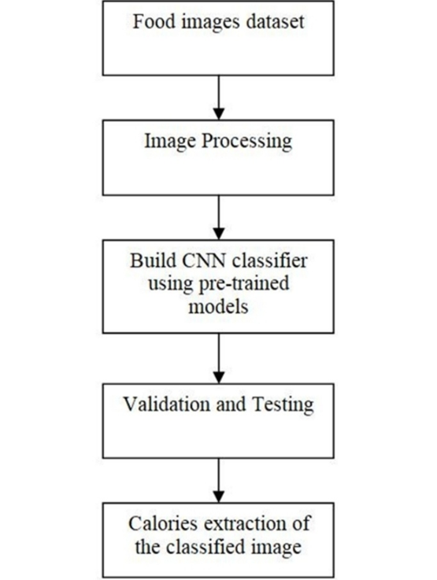

Fig. 3.2 Flowchart

1. Food Image Dataset - It contains different classes of food and each class has sample images. The dataset inherently comes with a lot of noise since there are images in which there is more than one food item. The image samples also contain a lot of colour and few of them are wrongly labelled too. The figure below shows the sample food images from the Indian Food dataset.
2. Image pre-processing - The dataset contains different classes of food images. Each class of image is divided into training and testing images wherein images from each class are considered as training samples and the remaining samples as test samples. Overall, there are training samples and test samples. The training set images are fed to the CNN model and validation is made using the test dataset.
3. Training the CNN classifier using pretrained models - The model will be using the technique of Transfer Learning for training the model - “Feature Extraction from pre-trained model and training a classifier using extracted features”.
4. Validation and Testing - Once the model is trained using the train dataset (the sample of data used to fit the model) then validated using validation dataset (The sample of data used to provide an unbiased evaluation of a model fit on the training dataset while tuning model hyper parameters.) and finally tested using the test dataset.
5. Nutritional facts extraction of the classified image - Our classifier can be used to estimate the calorific content of the classified food from the internet. Suitable python or any scripts can be used to perform web scraping to fetch the nutrition facts for the classified image from the web and provide it to the user.

**3.3 USE CASE DIAGRAM**

A Use Case Diagram is a lot of situations that reflect a client-frame relationship. A use case chart shows the entertainer-to-use relationship. Usage cases and on-screen characters are the two main elements of an usage case diagram. An on-screen character refers to an user or other person connected with the demonstrated process. A use case chart in figure is an out-of-the-box perspective that speaks to some activity each module will perform to complete an errand.

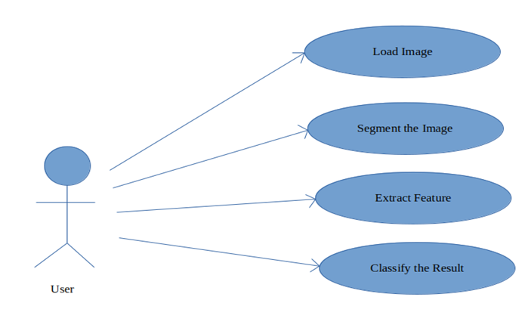

Fig. 3.3 Use-case Diagram

**3.4 DATA FLOW DIAGRAM**

Level: 0 describes the overall process of the project. We Input the image of the Food. System Classifies the Food Based on CNN

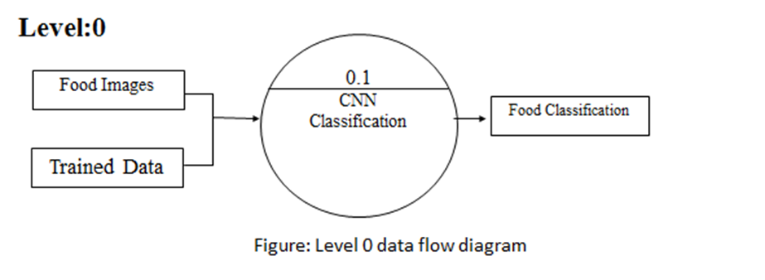

Fig. 3.4 Level 0 Data Flow Diagram

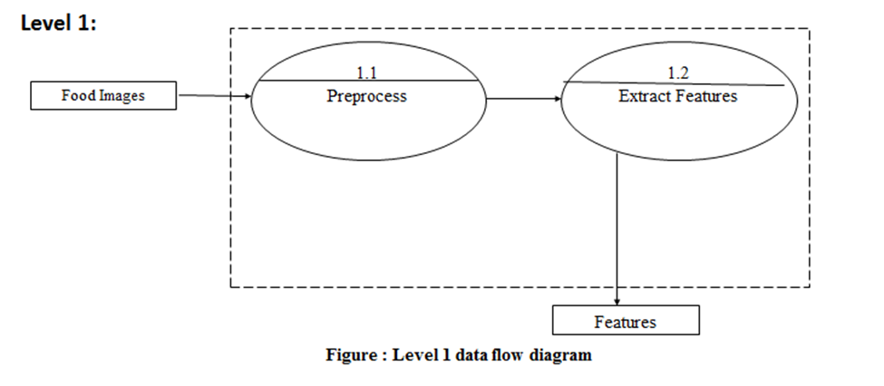

Fig. 3.5 Level 1 Data Flow Diagram

Level 2:

* Level 2 describes how Food is Classified
* System Classifies Food based on Data sets Trained and Extracted Features

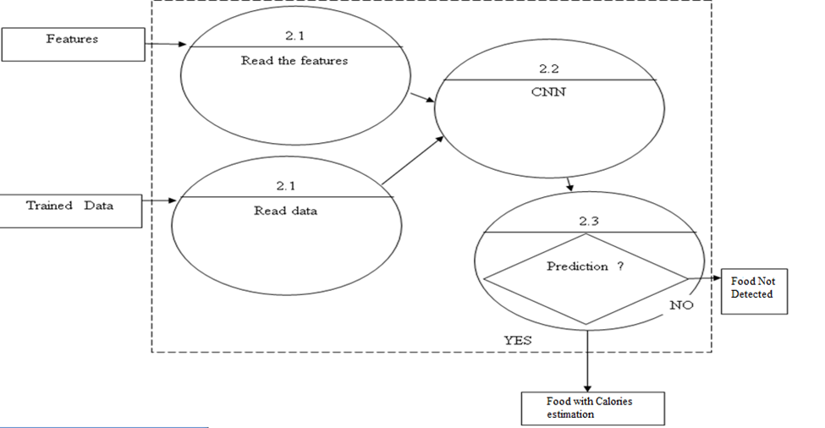

Fig. 3.6 Level 2 Data Flow Diagram

**CHAPTER 4**

**SYSTEM IMPLEMENTATION**

* 1. **LIBRARIES**

1. **OpenCV(open source computer vision library)**

Open source PC vision library and AI programming library. OpenCV is a cross-stage library utilizing which can grow constant PC vision applications. It chiefly centers around picture handling, video catch and examination including highlights like face identification and item location.

It can be used as:

import OpenCV

>>pip install cv2

1. **Keras**

Keras is an incredible simple to-utilize python library for creating and assessing profound learning models. It wraps the effective numerical calculation libraries theano and tensorflow and permits you to characterize and prepare neural system models in a couple of short lines of code.

The way it is used:

import Kereas

>>pip install keras

1. **Tensorflow**

Tensorflow is the essential programming device in profound learning. lt is an open source man-made consciousness library, utilized for information stream diagrams to manufacture models. Tensorflow is principally utilized for: discernment, arrangement, finding, getting, creation and forecast

The way it is used:

import Tensnrflow

>>pip install tensnrflow

1. **Imutils**

Imutils are a progression of comfort capacities to make essential picture preparing capacities, for example, interpretation, turn, resizing, skeletonization, and showing Matplotlib pictures simpler with OpenCV and both Python 2.7 and Python 3.

The way it is used:

import Imutils

>>pip install imutils

1. **Pillow**

Pillow is a Python 1maging Library (PIL), which includes support for opening or controlling or sparing pictures. The present adaptation Pillow recognizes and uses an enormous number of configurations. Compose suppon are deliberately limited to the most regularly utilized trade or introduction designs.

It can be used as follows:

import pillow

>>pip install pillow

* 1. **PSEUDO-CODE STEPS**

Step 1: Image/video acquisition from the input images

Step 2: Convert video to frames.

Step 3: Store images of each animal as database which is used as training set for our program

Step 4: Compare input image frames with the database.

Step 5: Use in read function to read the image and Preprocessing is done on that image. Perform Blob detection on the frame and blobs are matched with images from training database images.

Step 6: And check if it is matching or not.

Step 7: To identification calories in the food is desired or not. An array is created and program is written for Food to be identified.

Step 8: To obtain the count- we use if statements to increment count when identified

* 1. **ALGORITHM**

1. **Convolutional Neural Network (CNN)**

Convolutional neural framework is one of the principal category for the photos affirmation and pictures portrayals. Articles disclosures, affirmation faces, etc., are a bit of the regions where CNNs are commonly utilized. The Figure 7.2.1 shows the Neural Network with various convolutional layers. 1n certainty, the possibility of significant learning CNN models t can be used for train and attempted, every data picture will be adhered to the course of action of convolution layers with procedures (Kernals), Pooling, totally related layers (FC) by applying Soft max work can arrange an article with probabilistic characteristics runs some place in the scope of 0 and 1. The underneath figure is a complete stream of CNN to process an information picture and requests the articles subject to values.



Fig. 4.1 CNN Model

The invention of the CNN in 1994 by Yann LeCun is what propelled the field of Artificial Intelligence and Deep learning to its former glory. The first neural network named LeNet5 had a very less validation accuracy of 42% since then we have come a long way in this field. Nowadays almost every giant technology firms rely on CNN for more efficient performance. The idea to detect Calories in food incorporates the use of CNN before we dive into the “functionality and working of CNN” concept, we must have a basic idea on how the human brain recognizes an object in spite of its varying attributes from one another. Our brain has a complex layer of neurons ,each layer holds some information about the object and all the features of the object are extracted by the neurons and stored in our memory, next time when we see the same object the brain matches the stored features to recognize the object, but one can easily mistake it as a simple “IF-THEN” function, yes it is to some extent but it has an extra feature that gives it an edge over other algorithms that is Self-Learning, although it cannot match a human brain but still it can give it a tough competition . Image is processed using the Basic CNN to detect the Calories in Food. The data training in our CNN model has to satisfy following constraints:

1. There should be no missing values in our dataset.
2. The dataset must distinctly be divided into training and testing sets, either the training or the testing set shouldn’t contain any irrelevant data out of our model domain in case of an image dataset all the images must be of the same size, one uneven distribution of image size in our dataset can decrease the efficiency of our neural network.
3. The images should be converted into black and white format before feeding it into the convolution layer because reading images in RGB would involve a 3-D numPy matrix which will reduce the execution time of our model by a considerable amount.
4. Any kind of corrupted or blurred images should also be trimmed from the database before feeding it into the neural network. Now we have learned the data pre-processing rules, let us dive right into the working of the convolutional neural network.

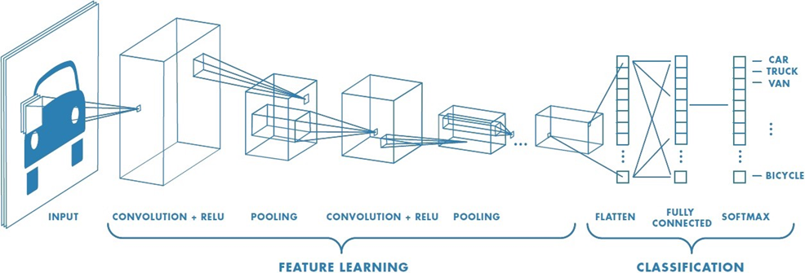

Fig. 4.2 CNN Layers

1. **Convolution layer**

This layer involves scanning the whole image for patterns and formulating it in the form of a 3x3 matrix. This convolved feature matrix of the image is known as Kernel. Each value in the kernel is known as weight vector.

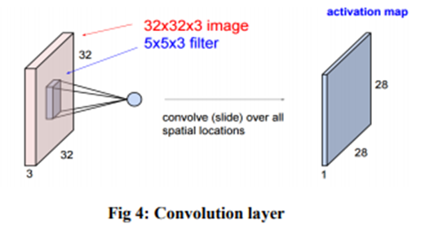

Fig. 4.3 Convolution Layer

1. **Pooling layer**

After the convolution comes to the pooling here the image matrix is broken down into the sets of 4 rectangular segments which are non-overlapping. There are two types of pooling, Max pooling and average pooling. Max pooling gives the maximum value in the relative matrix region which is taken. Average pooling gives the average value in the relative matrix region. The main advantage of the pooling layer is that it increases computer performance and decreases over-fitting chances.

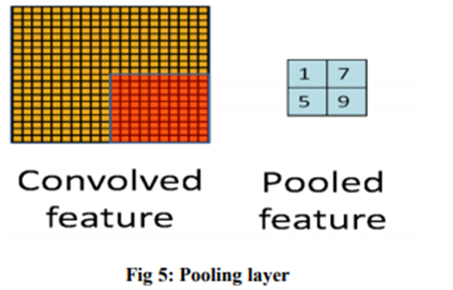

Fig. 4.4 Pooling Layer

1. **Activation layer**

It the part of the Convolutional Neural Networks where the values are Normalized that is, they are fitted in a certain range. The used convolutional function is ReLU which allows only the positive values and then rejects the negative values. It is the function of low computational cost.

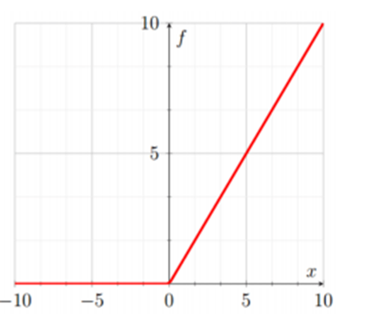

Fig. 4.5 ReLu function

1. **Fully connected layer**

Here the features are compared with the features of the test image and associate similar features with the specified label. Generally, labels are encoded in the form of numbers for the computational ease, they will be later converted into their respective strings.

**CHAPTER 5**

**TESTING**

* 1. **INTRODUCTION**

Testing helps and identifies the correct and complete quality of computer system software’s being developed. This technique predicts the quality of software’s being developed. To execute a program with the determination to find error which is often done to verify and validate is called testing a software system.

Software Testing is a method to check whether the actual software product matches expected requirements and to ensure that software product is Defect free. It involves execution of software/system components using manual or automated tools to evaluate one or more properties of interest. The purpose of software testing is to identify errors, gaps or missing requirements in contrast to actual requirements.

* 1. **TESTING METHODS**

Following are the methods involved in testing the software:

* Black-Box Testing
* White-Box Testing
* Grey-Box Testing
  + 1. **Black-Box Testing:**

This technique involves testing of the applications without having any prior knowledge of the interior workings of the application. The tester is new to the system architecture and doesn’t have access to source code. In the method the tester will interact with the system’s user interface by providing inputs and examining the outputs.

* + 1. **White-Box Testing:**

This involves detailed investigation of the internal logic and structure of the application code. This is also known as open-box testing. To perform this testing the tester needs to have technical know-hows about the application working and the code.

* + 1. **Grey-Box Testing:**

This is technique to test the application with a limited knowledge of the internal workings of an application.

* 1. **LEVELS OF SOFTWARE TESTING**

Following are the various methodologies that were used in the process of software testing:

* Unit Testing
* Integration Testing
* System Testing
* Acceptance Testing
* Validation Testing
  + 1. **Unit Testing**

This type of testing is basically performed by the developers before the setup is handed over to the testing team to formally execute the test cases. This is performed by the developer in his own perspective.

Our project was divided into a number of units, in each point of the development process the code was tested in our perspective to make sure we are proceeding in the right direction. Any errors encountered were sorted out immediately.

|  |  |
| --- | --- |
| Sl # Test Case : - | UTC-1 |
| Name of Test: - | Food Image Recognition |
| Items being tested: - | Detection of food |
| Sample Input: - | Tested for Different images |
| Expected output: - | Created blob For Nutritional Information |
| Actual output: - | Food Recognition is Successful |
| Remarks: - | Pass |

|  |  |
| --- | --- |
| Sl # Test Case: - | UTC-2 |
| Name of Test: - | Nutritional Facts detection |
| Items being tested: - | Detection of different type of Nutritional values in the food |
| Sample Input: - | Different images being tested |
| Expected output: - | Should not detect the objects other than food |
| Actual output: - | System did not detect any object other than food Calories |
| Remarks: - | Pass |

* + 1. **Integration Testing**

Integration testing is done after all the units of the system are combined to test whether the application is functioning in the desired manner after combining. It can be performed in two ways: Bottom-up and Top-down integration testing.

To test our application, we used Bottom-Up integration testing which begins with unit testing, followed by tests of progressively higher-level combinations of units called modules or builds.

|  |  |
| --- | --- |
| Sl # Test Case: - | ITC-1 |
| Name of Test: - | Input image and detection Food |
| Item being tested: - | Image capture and food detection |
| Sample Input: - | Click and select image |
| Expected output: - | Should detect food image |
| Actual output: - | Image captured and food image detected |
| Remarks: - | Pass. |

|  |  |
| --- | --- |
| l # Test Case : - | ITC-2 |
| Name of Test: - | Food Classification |
| Item being tested: - | Images with different Food |
| Sample Input: - | Image input |
| Expected output: - | Food Classification |
| Actual output: - | Food Classified and nutritional values predicted |
| Remarks: - | Pass. |

* + 1. **System Testing**

System Testing is a type of software testing that is performed on a complete integrated system to evaluate the compliance of the system with the corresponding requirements.­­

|  |  |
| --- | --- |
| Sl # Test Case : - | STC-1 |
| Name of Test: - | System testing |
| Item being tested: - | Detect and Recognize Food |
| Sample Input: - | Input image |
| Expected output: - | Should detect, classify food |
| Actual output: - | Same as expected output |
| Remarks: - | Pass |

* + 1. **Acceptance Testing**

This is arguably the most important type of testing, and is conducted by the Quality Assurance Team who will gauge whether the application meets intended specifications and satisfies the client requirement. Acceptance testing of our application involved testing the accuracy of the detected faces and checking whether the application recognized the faces correctly and ensuring that no mismatch occurs.

|  |  |
| --- | --- |
| Test Case ID | System Test Case 1 |
| Description | Image capture and automated Classification and testing |
| Input | Food Datasets |
| Expected Output | Functionality should be according to given criteria |
| Actual Result/Remarks | Working as expected output. |
| Passed (?) | Yes |

* + 1. **Validation Testing**

Validation testing is a black-box technique and is used to identify any errors and improvements in the software by observing the users through their usage and operation. We did validation testing at the ending phase after all the different units of our applications were integrated. At the culmination of integration testing, software is completely assembled as a packages interfacing errors have been covered and corrected, and final series of software tests-validating testing may begin. Validation can be defined in many ways, but a simple definition is that validation succeeds when software functions in a manner that can be reasonably expected by customers. Reasonable expectation is defined in the software requirement specification- a document that describes all users’ visible attributes of the software. The specification contains a section title “validation criteria”. Information contained in that section forms the basis for validation testing approach.

**CHAPTER 6**

**RESULTS**

Implementation is the process of converting a new system design into an operational one. It is the key stage in achieving a successful new system. It must therefore be carefully planned and controlled. The implementation of a system is done after the development effort is completed. This section comprises of a detailed project appearance and overview including the analysis part.

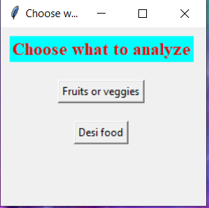

Fig. 6.1 First Page GUI

The above figure represents the initial page of the food analyzer where the user can choose between the type of food to be detected and evaluated.

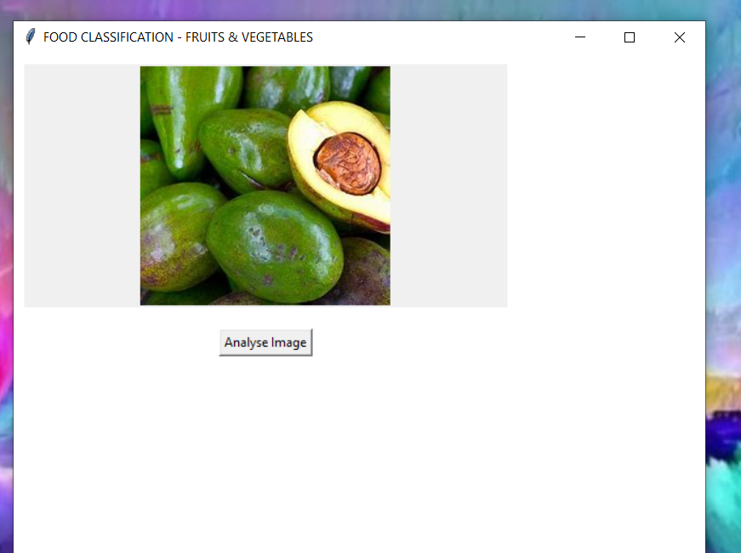

Fig. 6.2 Fruits/Vegetables Analysis

This figure represents the Fruits and vegetables section of the classifier. Thus, an image display box and a button appears, namely “Analyse Image”. The selected image is shown which was chosen by the user. The fruit selected is Avacado.

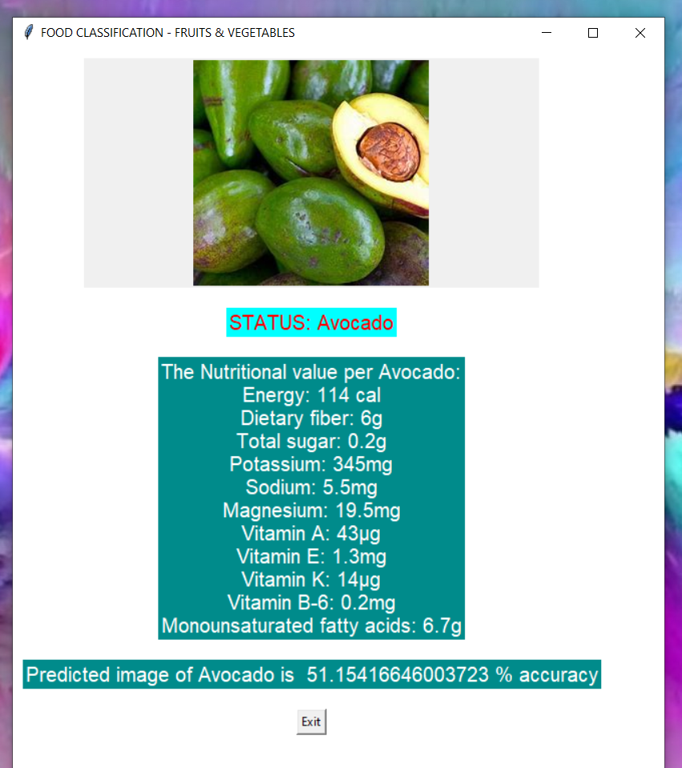

Fig. 6.3 Analysis Report for Fruit

This figure shows the final output of the food recognition and nutritional values in a structured manner. The implemented DCNN model correctly recognises and analyses the fruit and gives out the Status as Avocado. The nutritional value includes Energy, Dietary Fibre, Sugar Content and various minerals and Vitamins is also found to be correct.

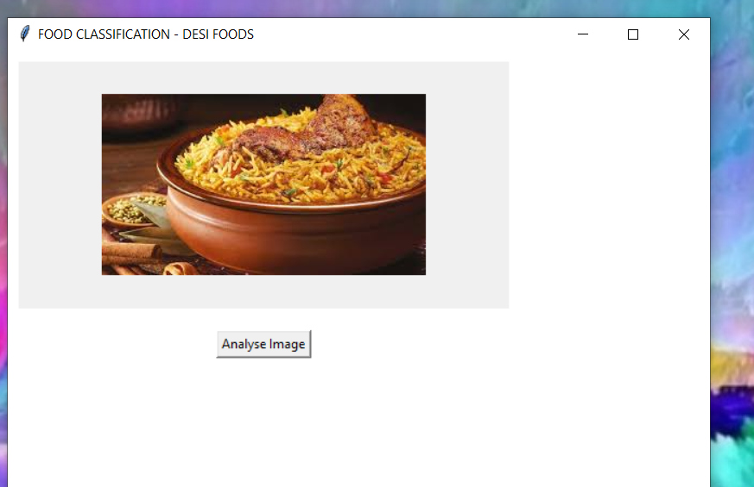

Fig. 6.4 Desi Food Classification

The above instance of the project depicts the Desi Food recognition and evaluation part. A Biriyani image is selected by the user.

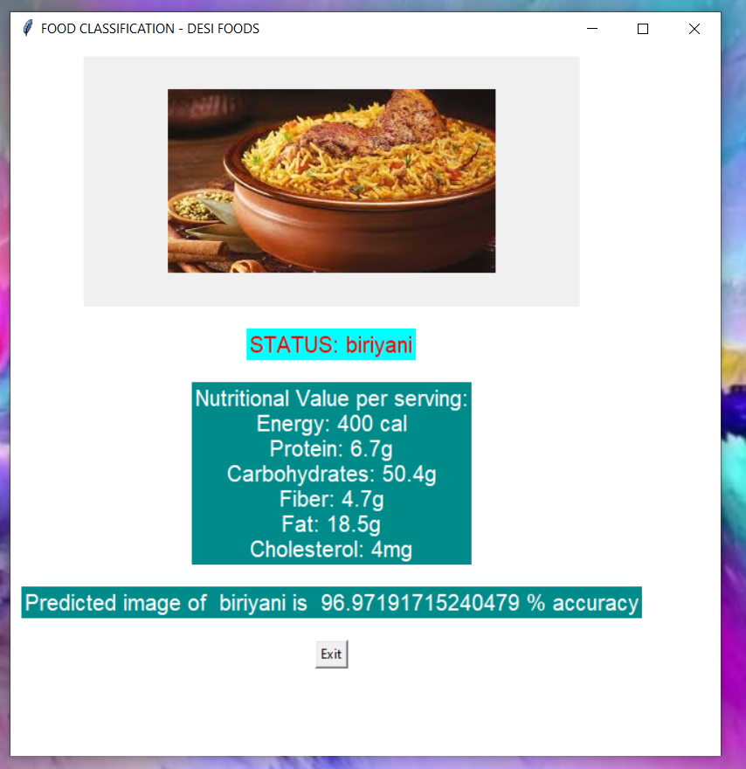

Fig. 6.5 Analysis Report for Desi Food

The STATUS is found to be Biriyani which is correct in recognition and also nutritional analysis is considerable. The recorded accuracy is found to be very high.

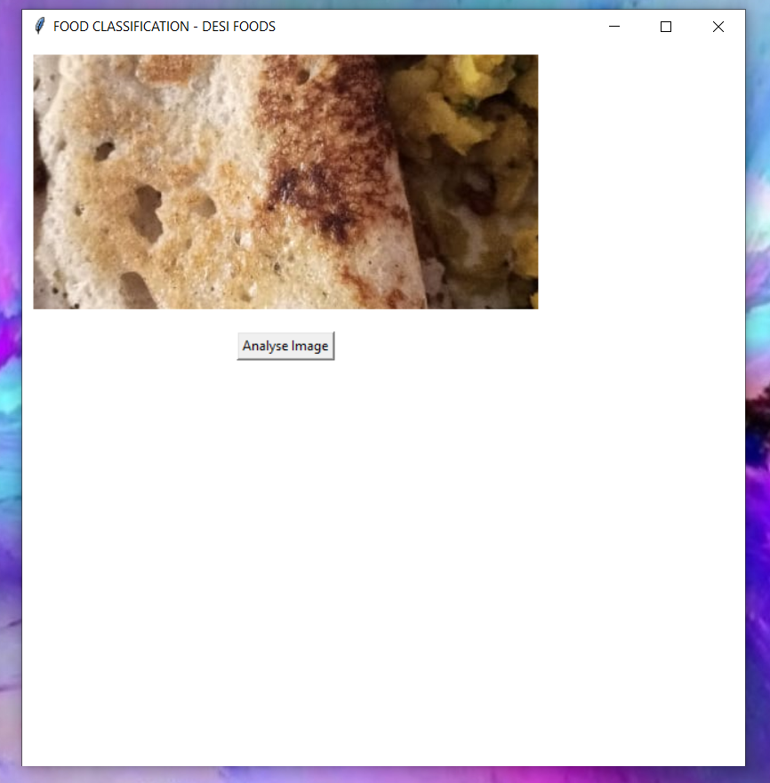

Fig. 6.6 Wrong Classification Instance

Another instance of the project is considered for deviated results than expected. The image chosen is Dose.

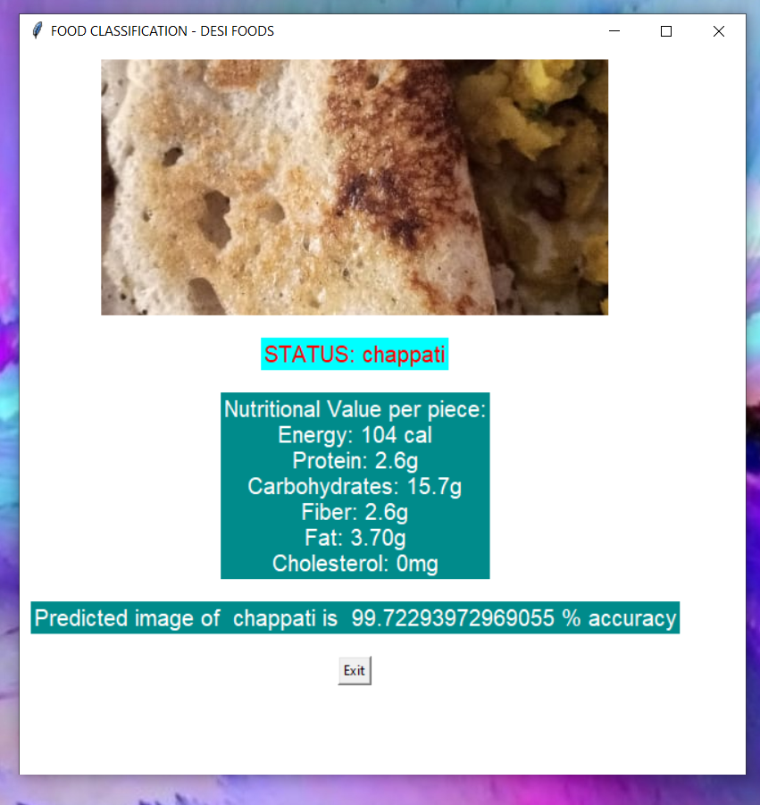

Fig. 6.7 Wrong Recognition and Report

The image shows that the recognition is wrong both in terms of accuracy and nutrition evaluation.

**CHAPTER 7**

**CONCLUSION**

In this research study of the Convolutional Neural Network, Deep learning technique is used to classify the food images into their respective classes and also predict the nutritional values of the food image.

The accuracy found in food images recognition was found to be considerable, however there is always room for more improvement in accuracy.

As far as the future enhancement is concerned, the task of classification can be improved by removing noise from the dataset. The same research can be carried out on larger dataset with more number of classes and more number of images in each class, as larger dataset improves the accuracy by learning more features and reduces the loss rate.

For this system to work efficiently, there is a need of high capable computing device and greater storage technologies. The model is slightly hindered due to limitations in our computing device. The system is flexible and more types of dishes can be accommodated easily with significance variance and complexities.

Furthermore, we have identified two more methods of Linear and Logical Regression which deliver even more better results. Therefore, further planning for improvement has been kept in mind to improve our approach towards health improvements.

**CHAPTER 8**

**REFERENCES**

[1] Jingjing Chen, Chong-Wah Ngo- “Deep-based Ingredient Recognition for Cooking Recipe Retrieval”

[2] Viswanath C Burkapalli, Priyadarshini C Patil- “An Efficient Food Image Classification By Inception-V3 Based CNN” (2020)

[3] Manpreetkour Basantsingh Sardar1, Dr. Sayyad D. Ajij2- “Fruit Recognition and its Calorie Measurement: An Image Processing Approach” (2016)

[4] Pathanjali C, Vimuktha E Salis, Jalaja G, Latha A- “A Comparative Study of Indian Food Image Classification Using K-Nearest-Neighbour and Support-Vector-Machines” (2019)

[5] Hemraj Raikwar and Himanshu Jain- “Calorie Estimation from Fast Food Images Using Support Vector Machine” (2018)

[6] Hokuto Kagaya and Kiyoharu Aizawa- “Food Detection and Recognition Using Convolutional Neural Network” The University of Tokyo.

[7] Thai Alimentation Image Classification by NaritHnoohom and SumethYuenyong

[8] Mohammed A. S ubhi and Sawal Md.Ali – “A Deep Convolutional Neural Network for Food Detection and Recognition”

[9] J. D. A. Berg and L. Fei-Fei, “Large scale visual recognition challenge 2010”

http://imagenet.org/download, 2010, [Online;accessed 29-Jan-2018]

[10] Szegedy, C., Vanhoucke, V., Ioffe, S., Shlens, J., Wojna, Z.(2016) “Rethinking the

inception architecture for computer vision. InProceedings of the IEEE conference on

computer vision and pattern recognition (pp.2818-2826)”